**Academic Year: 2023-24 Semester: V**

**Class / Branch: TEIT Subject: DevOps Lab**

**Name of Instructor: Prof. Sonal Jain/Prof. Neha Deshmukh**

# Experiment No. 10

**Aim: To install and provision master-slave configuration of Puppet by using AWS.**

**Theory:**

Developed by Puppet Lans, Puppet is an open-source configuration management tool used for automating and centralizing the configuration of infrastructure such as servers just like Ansible and Chef. It helps the simple execution of repetitive tasks which would otherwise be cumbersome and time-consuming.Puppet adopts a client-server architecture and comprises the following salient aspects.

**Puppet Master/Server** – This node contains all the configuration required to manage client nodes on which the puppet slave is installed.

**Puppet Slave** – These are the managed client nodes in your environment. All slaves are managed by the Puppet master and have the Puppet agent installed and running.

**PuppetDB** – This is a database that stores all the data generated by Puppet.

**Task 1: To create two EC2 instances as Puppet Master and Puppet Slave**

**Step 1: To add security group with following settings**

1. **Three inbound rules with “All traffic” for IPv6, IPv4 and my IP respectively.**

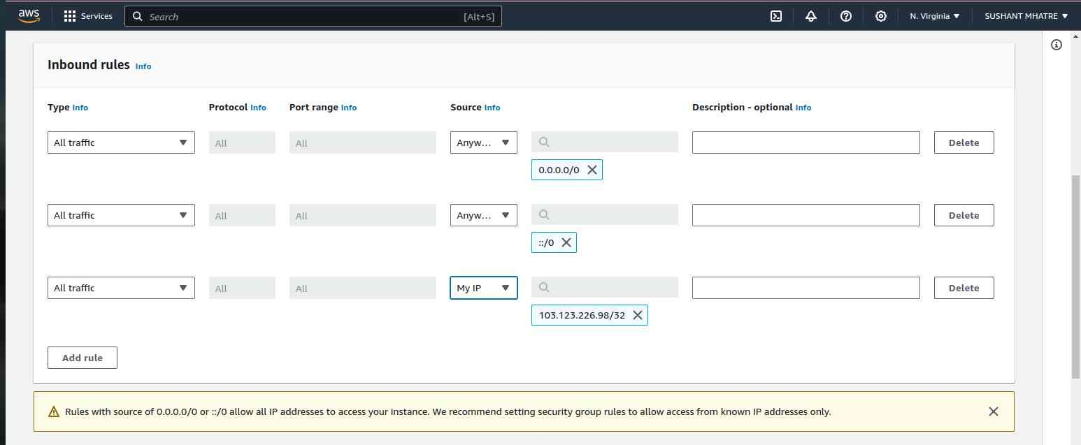

**Step 2: Create Key pair for using instances and save the file in local machine.**

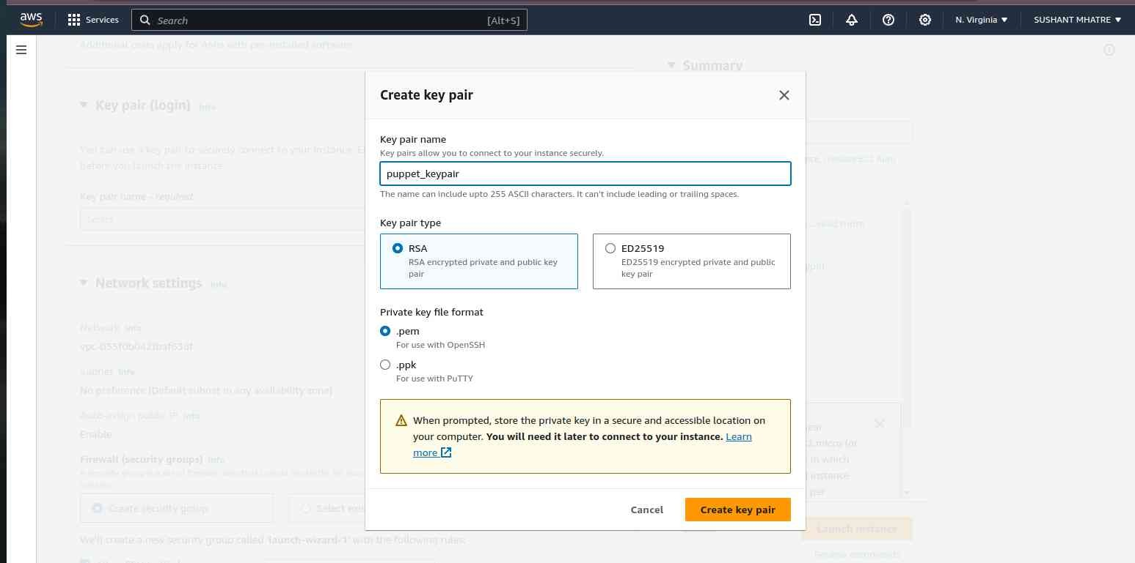

**Step3: Create Instances by choosing default setting with created security group and Key-pair**

**Note: 1. Choose Ubuntu free tier image(AMI)**

1. **Rename one instance as “Puppet_Slave”**

**Step 4: Connect AWS Instance using SSH for both master and slave (copy paste the command given under Connect 🡪 SSH**

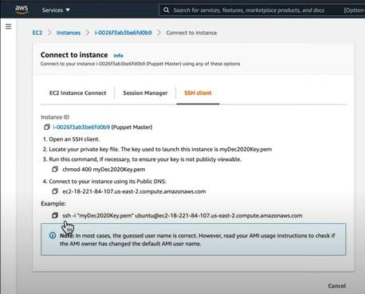

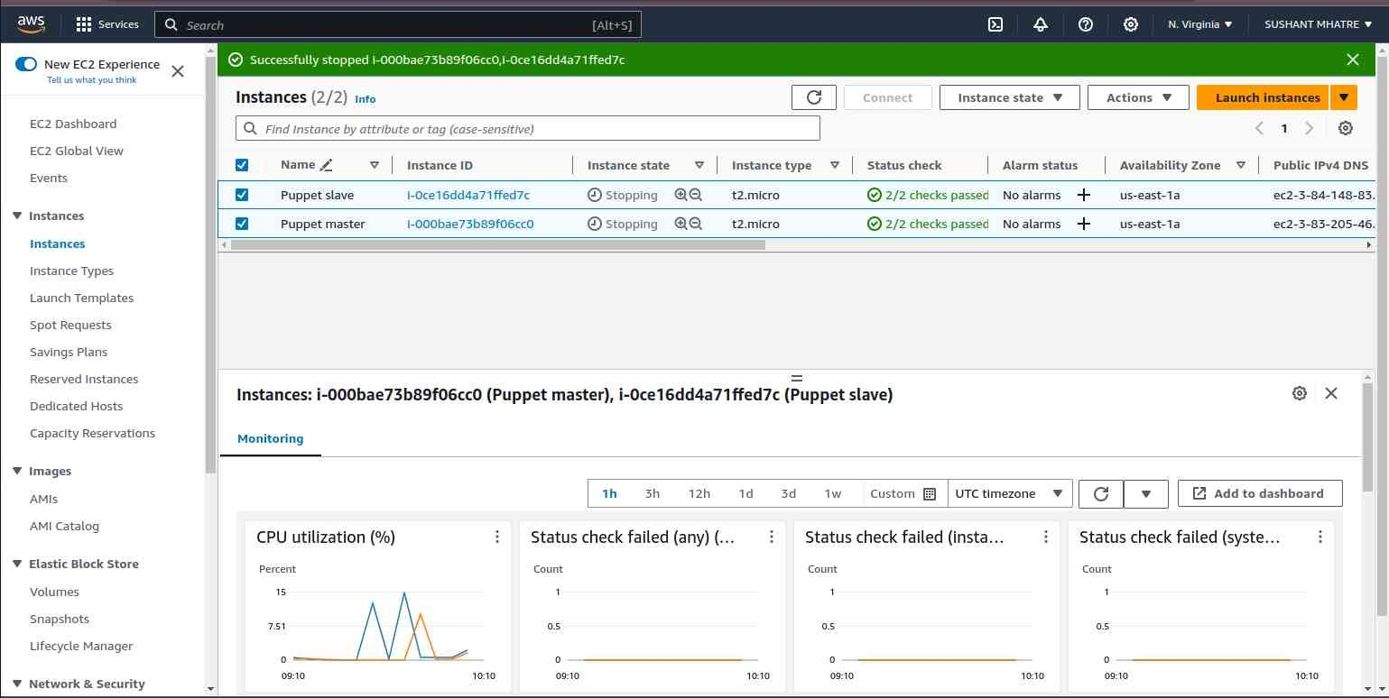

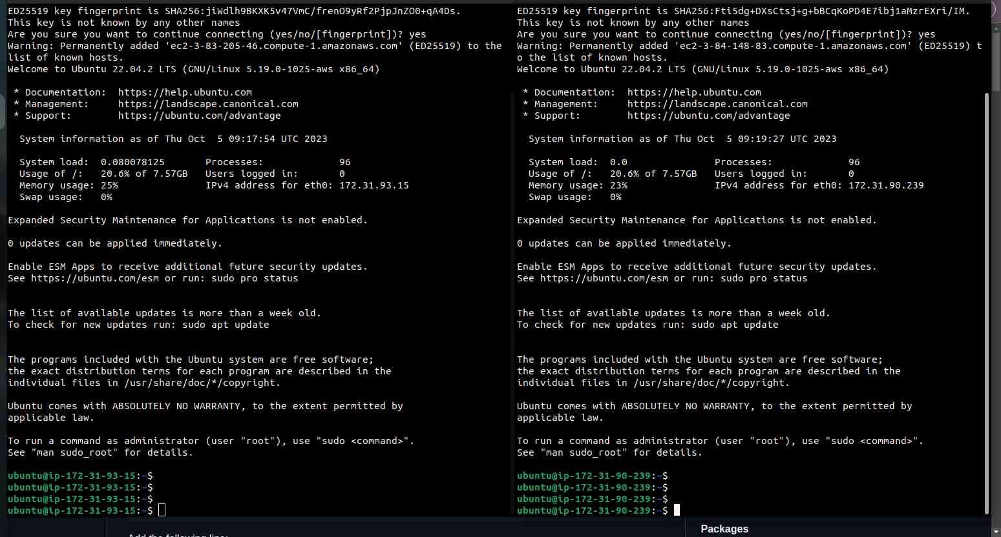

**Puppet Master and Puppet Agent Setup on AWS**

**Puppet Master Setup**

**Step1**: Modify the Puppet Master's hosts file

sudo nano /etc/hosts

Add the following line:

<Puppet_Master_Private_IP> puppet

**Step 2:** Download and install the Puppet Master packages

curl -O <https://apt.puppetlabs.com/puppet6-release-bionic.deb>

sudo dpkg -i puppet6-release-bionic.deb

sudo apt-get update

sudo apt-get install puppetserver -y

**Step 3:** Change the Memory Configuration of puppet default server from 2GB to 512MB

sudo nano /etc/default/puppetserver

JAVA_ARGS = "-Xms512m -Xms512m"

**Step4:** Allow traffic on port 8140

sudo ufw allow 8140

**Step5:** Configure and start Puppet Master

sudo systemctl enable puppetserver.service

sudo systemctl start puppetserver.service

sudo systemctl status puppetserver.service

**Puppet Agent Setup**

**Step6:** Modify the Puppet Agent's hosts file

sudo nano /etc/hosts

Add the following line:

<Puppet_Master_Private_IP> puppet

**Step7**: Download and install the Puppet Agent packages

curl -O https://apt.puppetlabs.com/puppet6-release-bionic.deb

sudo dpkg -i puppet6-release-bionic.deb

sudo apt-get update

sudo apt-get install puppet-agent -y

**Step8:** Enable and restart the Puppet Agent service

sudo systemctl enable puppet

sudo systemctl restart puppet

sudo systemctl status puppet

**Final Observation:**

Both master and slave machine must be configured successfully with status as “active”

# Conclusion:

In this experiment, we have successfully installed and configured puppet Master and Slave using by launching AWS EC2 instance.